<https://github.com/Saladino93/EnterpriseTech/blob/master/ScrapedPrices.ipynb>

Some nice researched stuff

<https://www.evernote.com/shard/s424/sh/136ec5b8-53a6-69cf-933c-000bc97d4617/edd3faa4c8b55e8250e7094738d1090d>

Some cute links:

<https://www.reddit.com/r/Entrepreneur/comments/961rr4/successfully_keep_your_prices_high_when_new/>

From comment here <https://www.reddit.com/r/Entrepreneur/comments/3fi5ya/how_the_hell_do_you_price_your_product/>:

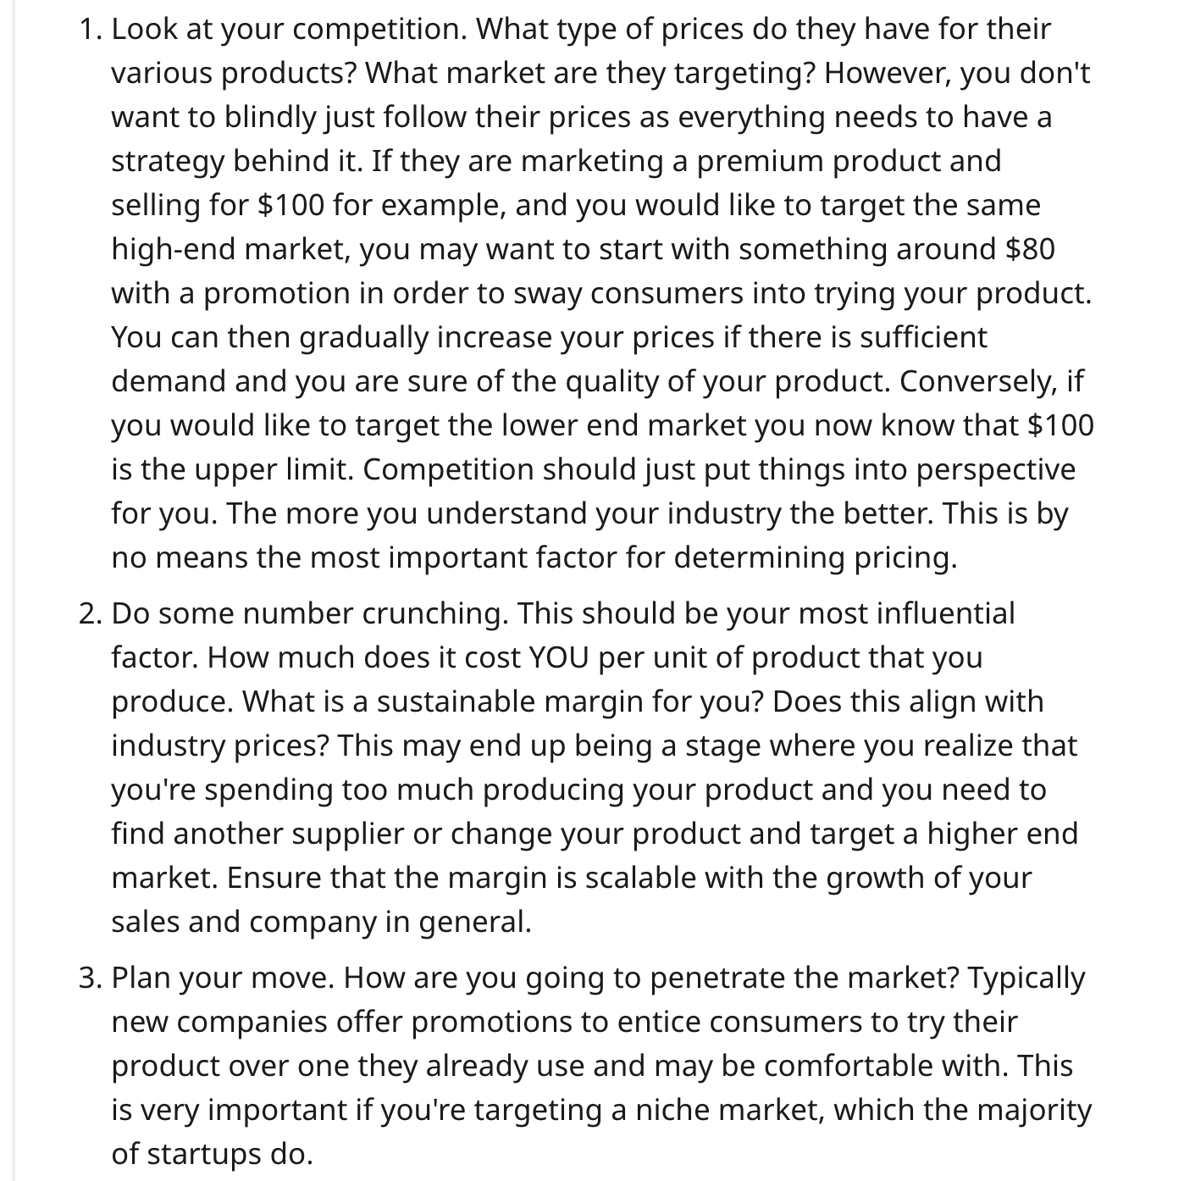

<https://www.reddit.com/r/marketing/comments/eutxza/pricing_strategies_of_software_solutions_in_b2b/>